Drug and Alcohol Abuse:
Prevention and Intervention

Purpose
Since the early 1960s, there has been an alarming increase in drug use in the United States. In 1964, four million Americans had tried an illegal drug. By 1999, that number had risen to 87.7 million (1999 National Household Survey on Drug Abuse).
Drug use among teens and even younger children has been steadily increasing for the past several years. According to the 1998 National Center on Addiction and Substance Abuse, teen marijuana use is up almost 300 percent since 1992. According to the Monitoring the Future Study in 1999, 55 percent of high school seniors reported having used an illegal drug, only 7 years before that, 41 percent said they had. Between 1991 and 1999, illicit drug use among younger children, 13 and 14-year-olds, increased by 51 percent, up from 18.7 percent to 28.3 percent.
Much is being done in the areas of intervention and prevention of drug and alcohol abuse.

Introduction
As a teenager, you have many new pressures in your life, as well as many new challenges and experiences. Along with these new opportunities come added responsibilities. While adjusting to these changes that are a part of becoming an adult, you are constantly making decisions. Sometimes you make good decisions and other times you may make mistakes. Making mistakes is normal and part of the learning process. Of course, nobody likes to make them, so try to analyze each situation beforehand to minimize possible mistakes.
When it comes to drugs, however, it is extremely important to make the right decision before you make a mistake. Making just one wrong choice could result in disastrous consequences. Having to juggle pressures from your family, school, activities, job, and friends may overwhelm you at times. The many new situations and emotions you experience can sometimes seem unbearable with no end in sight. Unfortunately, drugs and people who use them, and are willing to share them are readily available with what seems like a quick solution or retreat to any problem.

Pressures? You Need a Plan
Pressures from society, your family, friends, and even the pressures you place on yourself may sometimes make it difficult for you to say no to drugs. Our culture often encourages quick solutions to problems. Many people would like to believe that taking a pill could cure all types of problems, but there is no magic pill or cure-all. Pills and other drugs only produce chemical reactions in your mind and body that create artificial feelings and unhealthy side effects.
Oftentimes, advertising, movies, and television shows glamorize drug and alcohol abuse. It may appear that all the beautiful, fun people are drinking at a bar or taking a refreshing break with the “crisp, clean” smoke of a cigarette. These types of false messages reinforce the idea of drug abuse as a normal and desirable part of life. You may see your parents drink at parties; you may know students who use drugs. You may even be curious about drugs’ effects, or tempted to use them to relieve uncomfortable emotions. Though all these situations may make drug abuse attractive to you, the reality of drugs’ effects is far from glamorous. The pleasure drugs may give is short-lived and unreal. Drugs never solve problems; only you can do that. You cannot function if drugs are a problem in your life.

What you need is a plan of action to cope with all the pressures to abuse drugs. Once you decide that you do not want drugs to be a part of your life, you must develop strategies to resist these pressures as well as healthy alternatives to drugs.

Handling Internal Pressures
Accept and analyze your emotions.
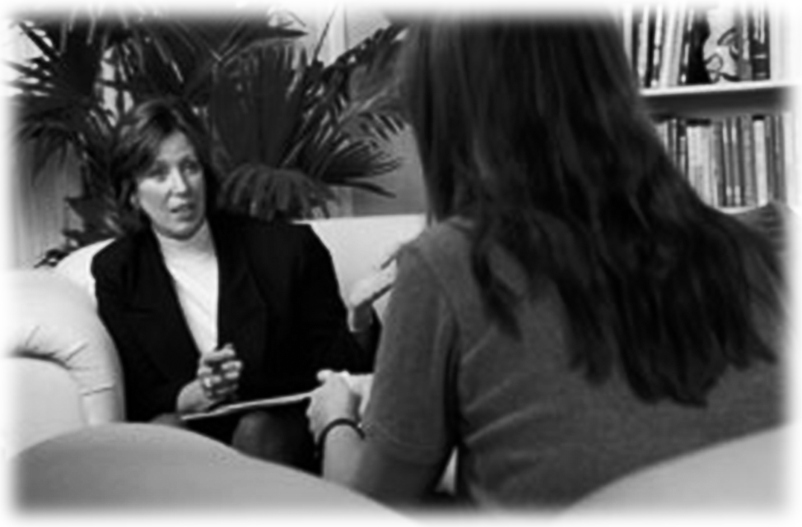
If you are feeling something unpleasant, take time to consider the cause of your emotions instead of trying to avoid feeling bad. If you do not address the cause, the uncomfortable feelings will return to bother you. Also, remember that certain amounts of anger, sadness, boredom, and frustration are normal human responses to life that must be accepted.
Seek out help when you feel overwhelmed
Members of your family, teachers, counselors, and friends can help you. There are also many places that offer help for specific problems, such as divorced parents, shyness, alcoholism, or lack of reading skills. You can ask a counselor or instructor at school about them or look for yourself in the phone book. If you are willing to make the effort, there are people willing to help you. Seek them out.
Find alternatives to drug use

If your routine is a big yawn, take a look around and see if there is an activity that looks interesting to you. There are better, safer, more rewarding experiences in life than using drugs. They involve doing something that you find exciting, satisfying, meaningful, and challenging. Some alternatives include sports, dancing, playing music, theater, volunteer work, tutoring, writing, reading, playing games, photography, or crafts. You can find out about other alternatives by asking organizations in your community about programs they offer. Check with schools, community colleges, adult education programs, YMCA, YWCA, Boys' or Girls' Clubs, libraries, etc. Photography, auto mechanics, painting, chess, drama, singing, playing an instrument, and part-time employment are among the many activities you could do that would add new challenges to an unexciting routine. Of even greater importance, these activities pay you back with a real sense of accomplishment and heightened self-esteem as you get better and better at them. Drugs cannot give you these benefits; they can only temporarily produce a false feeling of well-being. In the long run, drugs always take far more than they give and leave the user with nothing but problems.

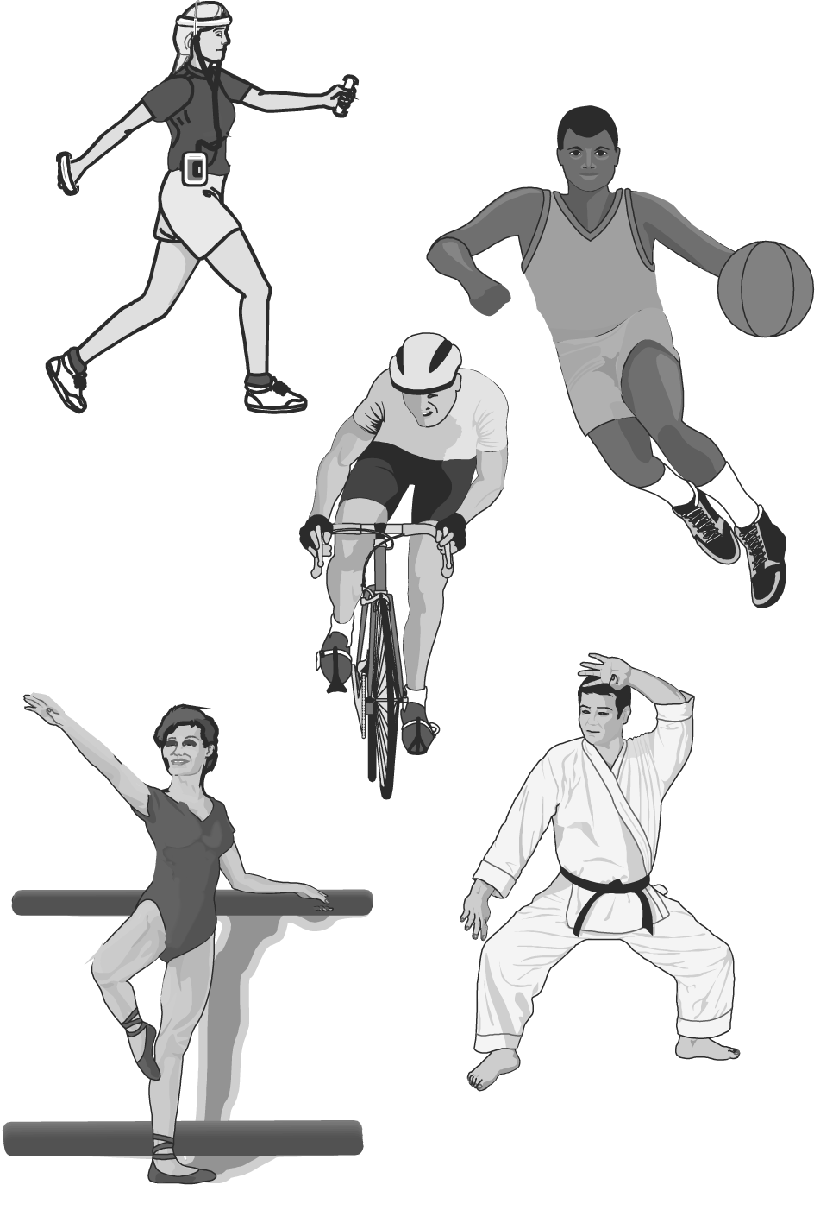
Release excess energy and learn how to relax.
If you cannot sit still in your seat during class, maybe you are not exercising your body enough. Physical activities such as running, walking, biking, tennis, basketball, weight training, martial arts, skiing, and dance, among others, keep your body in shape while relaxing and focusing your mind during mental activities.
Practice patience
If there is a situation that makes you feel bad, you cannot think of a way to change it, and nothing you do seems to work, what can you do? Wait! You may not like that answer, since waiting is difficult, especially for young people. But there will be times in life when the situation is out of your control. This fact is understandably hard for young people to accept. However, change is certain and inevitable. If you wait and stay alert, new solutions and opportunities will become available to you in time. To cope with the stress of a difficult situation until things do change, follow the tips in the chapter on stress to learn coping strategies. People on drugs never learn the lesson of patience; they miss opportunities to change their lives for the better.

Resisting External Pressure
Learn how to refuse drugs effectively
Standing up to peers when they want you to do something that you do not wish to do can be very difficult. When you go against the crowd, you risk rejection – and that is scary. However, every time you make a decision to do what is best for you and those you care about, you become a stronger person. You also gain the respect of those people who are your true friends. Your strength and your decisions may even give others the courage to do what is best for them as well. In today’s school environment, saying no may not be easy, but it is definitely worth the effort.
Prepare yourself for situations where you may be offered drugs
Visualize different circumstances and different behaviors you can use to refuse offers of drugs. Have answers ready:
- No, thanks, I’d rather do something else.
- No, I already feel fine.
- No, thanks, I already have enough problems.
- No, I’m running in the meet tomorrow (interviewing for a job, taking an important test, acting in a play, etc.).
- No, thanks, I’ll pass.
- No, I don’t like the way it smells, tastes, makes me feel, etc.
- No, I’m not feeling too well, and I don’t want to get worse.
- No!
If you do not feel comfortable saying no in a situation, find a way to remove yourself from the scene. Suddenly remembering an appointment or some other excuse can get you away from the situation and give you time to think of another way of handling it next time. The important thing is not to do the drugs.
Analyze media and advertising
Does advertising accurately project the image of drugs? Who gains by making products appear glamorous and sophisticated? People who sell products want you to buy them and will use psychological techniques in advertising to create a demand for their goods. Companies that sell beer, cigarettes, and non-drug related products, such as cars, have one main goal – they want your money.
Your goal is to do what is best for you. Some products that advertising tries to sell you are opposed to that goal. Your defense against advertisements for products that are useless or harmful is the power to read between the lines. Think about the message an ad is giving and decide for yourself whether it is accurate.

Legal Risks of Illegal Drug Use
Before deciding to drink alcohol or abuse drugs, remember that abuse of legal drugs, taking illegal drugs, underage drinking, and driving while intoxicated are all against the law. By endangering their lives and the lives of others, users become a societal problem, often requiring legal punishment.

Drug laws vary from state to state, but the general trend throughout the United States is toward stiffer penalties for those convicted of drug possession, drug selling, and alcohol-related car accidents. People convicted of these crimes must pay higher fines and must often spend time in jail. If you think experimenting with drugs might be fun, think about how much fun you would have spending time in a prison.

Prevention History
Historically, various organizations, communities, and governmental agencies founded drug abuse prevention programs based on the theory that people used drugs because they were ignorant of the consequences of such use. According to this theory, failure to recognize any negative effects of drugs resulted in neutral or even positive attitudes toward experimenting with drugs.
During the 1960s, drug education programs focused on providing information. Administrators of those programs often called them “fear arousal messages,” because they dealt with health and social consequences of drug use. However, these programs were somewhat ineffective because youths said that the messages themselves lacked credibility.
By the 1970s, social scientists began to address more personal factors that influenced drug abuse behavior among children and adolescents. Studies showed that a close association exists between drug abuse and a person’s attitudes, beliefs, and values, as well as other personality factors such as feelings of self-esteem, self-reliance, and alienation.
One prevention approach that grew from this research was affective education. Rather than focusing on drug abuse behaviors, affective education focused on the factors associated with use. This approach attempted to eliminate the reasons for using drugs by creating a school climate that was supportive of students' social and emotional needs. These programs often focused on training the students in effective decision-making skills. Students in these programs worked to clarify their values, analyze behavior consequences, and identify alternative behaviors.
Some of the other leading prevention approaches in the 1970s focused on alternative activities to drug use. These programs involved youths in community projects to reduce alienation, while others provided alternative opportunities for recreation, socialization, and informal education.
Prevention Today
Today, many schools have drug prevention programs. Sometimes these programs directly involve the students. For example, high school students might perform as “peer” teachers for 7th graders. Some studies have shown that prevention programs led by peers are more effective than programs led by adults. The health programs led by peers were more successful at preventing nonsmokers from smoking. Through role-playing, students acted out situations requiring resistance to peer pressure. Students also made social commitments not to smoke or use drugs.
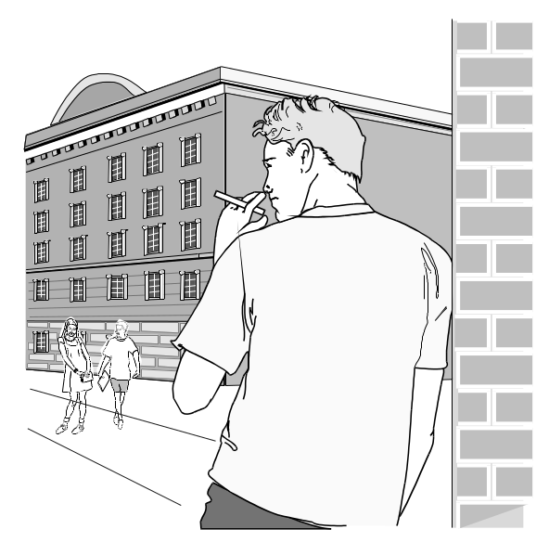
For most youths, substance abuse appears to be the result, in large part, of social influences. Thus, teaching youths to resist these influences is one approach to the prevention of drug use. However, not all youths use drugs for the same reason or respond to the same prevention approach. Thus, it may not be effective to focus on any single prevention approach, and it is important to explore multiple strategies.
Changing the Social Environment
Substance abuse prevention programs that focus on changing an individual’s negative social environment can be very successful in reducing the risks of early drug use. By changing a teen’s surroundings, he or she is more likely to develop positive personal attributes and behaviors and will then be more likely to choose alternatives to drug and alcohol use.
In some instances, teenagers live in a high-risk social environment that supports and even encourages the use of drugs and alcohol. Often a teen has only negative role models to follow and easy access to drugs and alcohol in his or her home or community. However, not all teenagers in high-risk environments choose to experiment or use drugs or alcohol regularly. Teens who possess positive intrapersonal (within the individual) values, attitudes, and skills may be most successful in resisting drugs and alcohol, despite a negative, high-risk social environment. These teens are able to choose non-drug alternatives that meet their needs.
Research suggests prevention efforts should focus on both changing the environment and building positive values, attitudes and skills (such as decision-making), rather than only focusing on a single factor. These findings also suggest that teen drug and alcohol use is functional. In other words, the functions that drugs serve an individual (reducing pain, providing excitement, etc.) need to be replaced with much more positive activities and rewards that will meet the teenager’s needs. In addition to replacing the functions served by drugs, substance abuse prevention efforts should focus on those factors (social environment, negative role models, easy assess to drugs and alcohol, etc.) that seem to be predictors of drug use.
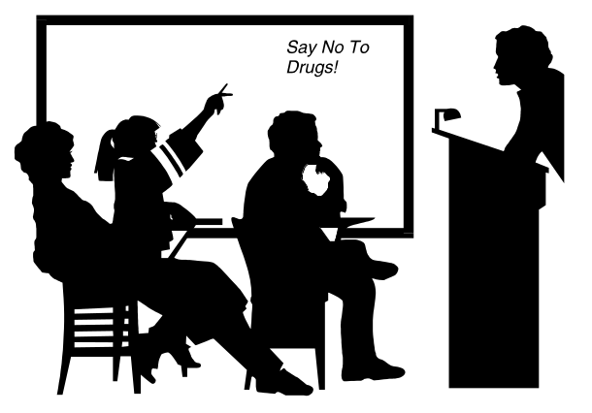
Some research suggests that prevention efforts should focus on this functionality and provide alternative behaviors for drug use rather than simply trying to suppress the underlying need or reason for using drugs or alcohol. This research also suggests that peers and parents should offer teens positive rewards for choosing alternatives to drug use.

Reaching Youth Outside the Classroom: Big Brothers & Big Sisters of Wichita, Kansas
For nearly a century, Big Brothers & Big Sisters of America (BBBSA) has been providing adult support and friendship to children. Through a careful matching process, volunteers interact regularly with young people in one-to-one relationships. Of the 514 local BBBSA agencies nationwide, a Big Brothers & Big Sisters program in Wichita, Kansas, was the largest with over 1300 matches of adult mentors with area youths in 1999. The goals of this mentoring program are to prevent destructive behavior and promote positive attitudes and habits among youths through support, role modeling, and exposure to healthy activities. A study conducted in 1992-1993, with nearly 1,000 boys and girls ages 10-16 in eight cities, found that following 18 months of a mentoring program where the mentors met about three times each month produced several positive results. Little Brothers and Sisters were:
- 46% less likely to begin using illicit drugs;
- 27% less likely to begin using alcohol; and
- 53% less likely to skip school than their peers.

Another Outside the Classroom Success Story: Self-Expression Teen Theater, Toledo, Ohio
Self-Expression Teen Theater (SETT) trains youths to educate their peers about the dangers of alcohol and other drug use, premature sexual activity, and other risky behaviors, and explores positive, alternative activities. The program was begun in 1986 in response to a needs assessment, that revealed Hispanics and African Americans in Toledo had high rates of alcohol and other drug use. Since it began, SETT has trained over 1,200 peer educators, given more than 500 performances, and conducted over 200 youth-led workshops focusing on substance abuse and its relation to violence.
SETT targets primarily Hispanic and African American youths ages 11-18 to be peer educators. These young people conceive, write, and perform skits on topics including violence, substance abuse, teen pregnancy, suicide, and academic failure. Performances illustrate the importance of communication between young people and adults, and provide youths with information on prevention and treatment services where they can seek help. The troupes perform in schools, churches, public housing projects, and malls.
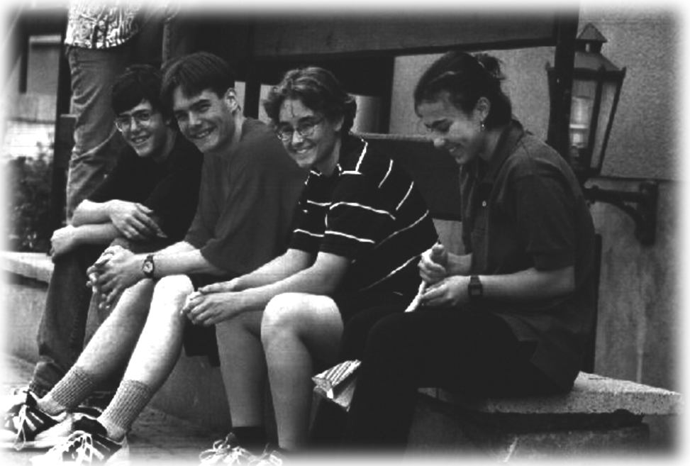
In the program’s target area of Toledo, 60% of all students graduate from public high schools. However, 93% of SETT peer educators graduate from high school, and 87% are attending or have graduated from college.

An In-School Program: Reconnecting Youth, Midland, Texas
Reconnecting Youth is a school-based drug prevention program targeting high-risk high school students. The program is designed to reduce drug use and aggression, as well as academic failure and dropping out of school. Reconnecting Youth includes a semester-long course, school-bonding activities, and a school system crisis response plan. The Reconnecting Youth class is taught 55 minutes each day and includes four modules: Decision-Making, Personal Control, Self-Esteem Enhancement, and Interpersonal Communication. Studies documented that Reconnecting Youth improved academic performance; decreased drug use; reduction in anger, depression, hopelessness, aggression, suicidal behaviors, and stress; improved self-esteem, self-control, bonding to school, and social support.

School-Based Programs that Reach Beyond the Classroom
In schools that have components beyond the basic classroom program, they aim their efforts at changing the adolescent's social environment. Newsletters to parents emphasize the importance of communication with their child about drug abuse and include homework assignments such as structured interviews to help achieve better communication. Peer leaders clarify school rules as they tell their classmates the rules on drugs and the reasons for those rules. An alternatives week, planned by peer leaders, promotes and reinforces healthy behaviors. Finally, program administrators facilitate smoking cessation programs for interested parents.

Drug Abuse Prevention
There are many ways in which you can become involved in drug abuse prevention. You might be able to volunteer at drug treatment and rehabilitation centers. Look in the phone book under “drug abuse” for information and prevention programs. You may be able to find several local sources for preventive information. There are also toll-free numbers that provide information on drug abuse and prevention.
Many major hospitals have chemical dependency hospitals affiliated with them. These hospitals may offer professional treatment for alcoholism and drug dependency. Some may offer services such as seminars on drug recovery, depression, or anxiety and other individualized programs.
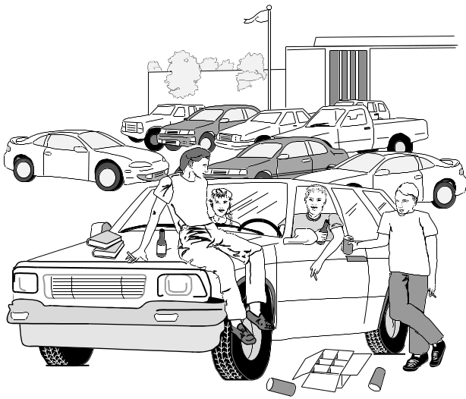
Help and/or information are available from many private and public agencies, facilities, and people. Drug treatment centers and clinics specialize in treating people with drug problems. Hospitals treat on an in- or out-patient basis. Mental health centers can treat people with drug problems by dealing with underlying problems. Public health agencies and social service agencies can provide practical advice and make referrals. Halfway houses provide residential treatment for those with drug problems.
Treatment and Referral Services
The National Drug Information and Treatment Referral Hotline (1-800-662-HELP), and the Substance Abuse and Mental Health Services Administration (SAMHSA’s Center for Substance Abuse Treatment , or CSAT) provide drug-related information to individuals seeking local treatment programs and direct friends or family members to support groups or services.
To learn more information on alcohol and other drugs, write or call: National Clearinghouse for Alcohol and Drug Information (NCADI) at 1-800-729-6686 for assistance in English or Spanish. PREVLine (Prevention On-Line), a 24-hour Web-based prevention information portal and search engine, is maintained by the U. S. Department of Health and Human Services and SAMSHSA’s Center for Substance Abuse Prevention (CSAP). Information can be found on the Internet at http://www.health.org.
If you need help with a cocaine problem, call Cocaine Anonymous at 1-800-347-8998 or write for free materials to: 3740 Overland Avenue, Suite C, Los Angeles, CA 90034.
For information about inhalant prevention, contact the National Inhalant Prevention Coalition, 322 A Thompson Street, Chattanooga, TN 37405, or call 1-800-269-4237.
Don’t forget to call your local police department, health department, and local drug prevention organizations for more information on drugs.

Alcohol Abuse Prevention
Alcoholics Anonymous (AA) is a worldwide group of men and women who help each other maintain sobriety. Members who attend meetings share their recovery experiences freely with others who may have a drinking problem. The AA program consists basically of “Twelve Steps” designed for personal recovery from alcoholism. The organization functions through almost 97,000 local groups in 114 countries. The program has helped more than 2,000,000 problem drinkers. Several hundred thousand alcoholics have achieved sobriety in AA, but members recognize that their program is not always effective and that some may require professional counseling or treatment.
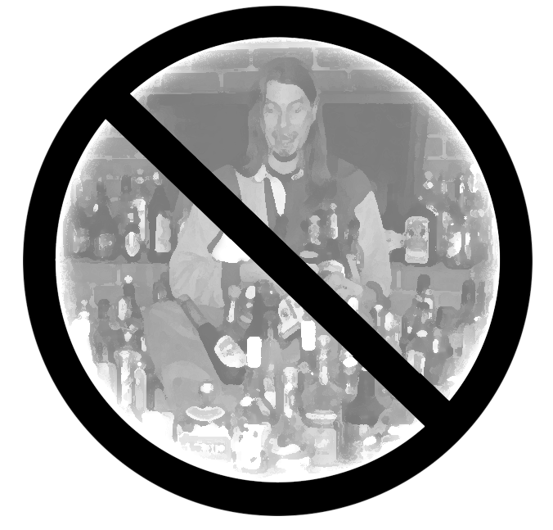
Look for Alcoholics Anonymous in any telephone directory. In most urban areas, a central AA office can answer your questions or put you in touch with AA members. If AA is not in your local directory, write the General Service Office, P.O. Box 459, Grand Central Station; New York, NY 10163 or call (212) 870-3400
Al-Anon is a worldwide organization that offers help to families and friends of alcoholics. Al-Anon meetings are held in 115 countries. There are over 24,000 Al-Anon and over 2,300 Alateen groups worldwide. Members receive support through a mutual exchange of experiences about how an alcoholic has affected their lives. Alateen is a fellowship of young Al-Anon members, usually teenagers, with someone else's drinking problems affecting their lives. Young people come together to share experiences, strengths, and hopes with each other as they discuss their difficulties. They can also encourage one another to learn effective ways to cope with their problems.
To contact the nearest Al-Anon or Alateen Group, call the local Al-Anon Information Service (Intergroup) in metropolitan areas, or write: Al-Anon Family Group Headquarters, Inc., 1600 Corporate Landing Parkway, Virginia Beach, VA 23454; (Email) wso@al-anon.org; (Phone) (757) 563-1600; (Fax) (757) 563-1655.
There are many other places that people can get help for problems caused by alcohol. They can talk with family, friends, a school counselor, or a doctor. Look in the yellow pages under “alcohol” or “alcoholism.” Use referral services and get information provided by the local affiliate of the National Council on Alcoholism (1-800-NCA-CALL). Remember, it is important to seek help and support for people with drinking problems.

Driving Under the Influence
Disturbing Statistics
According to the National Highway Traffic Safety Administration (NHTSA), there were 41,611 total traffic fatalities in 1999. Of those, 38% or 15,786 were alcohol-related.
Estimates are that 2,104 persons aged 16-20 died in alcohol-related crashes in 1998. (NHTSA, 1999)
An estimated 308,000 persons were injured in crashes where police reported alcohol was present – an average of one person injured approximately every 2 minutes.
Approximately 1.4 million drivers were arrested in 1998 for driving under the influence of alcohol or narcotics. This is an arrest rate of 1 for every 132 licensed drivers in the United States. (NHTSA, 1999)
About 3 in every 10 Americans will be involved in an alcohol-related crash at some time in their lives.
MADD
According to Mothers Against Drunk Driving (MADD), underage drinking is America's No. 1 youth drug problem, killing 6.5 times more young people than all other illicit drugs combined.
Founded in 1980, MADD is a non-profit grassroots organization with 600 affiliates and approximately two million members and supporters nationwide. MADD's prevention efforts focus on drunk driving and underage drinking; these efforts have helped save more than 183,000 lives since the organization's founding. Although alcohol-related traffic deaths have decreased by more than 40 percent since MADD's founding, drunk driving still remains the nation's most frequently committed violent crime.
DID YOU KNOW?

Drinking is the third leading cause of death in the United States – right behind heart disease and cancer.
Since its founding, MADD has helped pass more than 2,300 anti-drunk driving and underage drinking laws. MADD was instrumental in the passage of the national 21 minimum drinking age law in 1984, as well as the 1995 “zero tolerance” provision of the National Highway Systems Law making it illegal for those under 21 to drive after consuming alcohol. On October 23, 2000, President Clinton, with the support of MADD, signed a federal law that will require each state to pass .08 BAC as the legal limit or lose a portion of their federal highway funding. MADD is working to pass .08 BAC (blood alcohol concentration) laws in the 31 states that do not yet have this law. MADD also advocates for passage of a federal constitutional amendment for victims' rights and stricter penalties for repeat and higher-risk drunk driving offenders, in addition to other key legislation in states across the country.
MADD is always looking for dedicated individuals interested in starting a chapter or Community Action Team (CAT) in areas where MADD does not have a local presence. Because the procedures for starting a chapter vary by area, MADD’s website recommends that you contact their national office at 800-438-6233 and ask the operator for the Field Services Coordinator for your state. You can write to MADD at the following address: 511 E. John Carpenter Freeway, Suite 700, Irving, TX 75062. Their Internet address is www.madd.org.

Know When to Say When
“Know When to Say When,” which was in effect from 1985 to 1999, was a nationwide consumer education campaign developed by Anheuser-Busch that encouraged consumers to be responsible when they drink. It aimed at normally responsible, law-abiding citizens who only needed reminders of their legal and moral obligations to themselves and others. The purpose of the campaign was to help create a climate that strongly discourages “situational abuse.” The campaign involved a series of television commercials, a movie, billboards, and newspaper advertisements that reminded consumers not to overindulge. On September 12, 1999, the company launched a new advertising campaign, “We All Make A Difference.” It reflected the fact that today's challenge is not to convince the public that drunk driving is inexcusable and wrong (the public already knows that). Instead, it aimed to reinforce the good practices of drinkers who exercise personal responsibility, designate a driver or call a cab, and build on the momentum of the positive trends.
SADD
Students Against Destructive Decisions (SADD) is a school-based organization dedicated to addressing the issues of underage drinking, impaired driving, drug use, and other destructive decisions and killers of young people. SADD's mission is to provide students with the best prevention and intervention tools possible to deal with the serious issues young adults are facing today. Empowerment is the foundation of SADD. The idea of empowerment is to build students' confidence and ability to create changes and manage behavior in a way that results in healthy choices. SADD promotes a “no use” message of alcohol and other drugs and encourages students not to participate in activities with destructive consequences.
For information about starting a SADD chapter at your school, start by calling SADD National Headquarters at 1-877-SADD-INC, or filing a request for information on SADD’s website, http://www.saddonline.com. You can also order a SADD chapter starter kit from SADD at 1-800-394-0090.

Important Tips to Know
Your knowledge of the following tips can possibly save a life when you are in a position to influence family members, friends, or other adults who are planning and/or attending a social function that includes alcohol.
As Responsible Adults…
- Recognize that every social occasion does not have to include alcoholic beverages.
- If alcohol is served, place limits on the amount available. Estimate how much alcohol to have on hand, based on the number of guests and the length of the party. As a guideline, plan on one drink per guest per hour; then, purchase only that amount.
- Provide other activities when serving alcoholic beverages. Drinking should not be the main purpose of any activity.
- Create a climate that respects individual choice by providing attractive non-alcoholic drinks. Be conscious of the drinking age and remember that serving alcohol to those under 21 is illegal!
- Serve snacks so that guests do not drink on an empty stomach, and to slow down alcohol absorption.
- Create a climate that discourages overindulgence, but assume responsibility for guests who overindulge. See that they get home safely by providing or arranging transportation or invite them to stay later or overnight.
- Keep a list of telephone numbers of emergency health care, police, and taxi services in case you have a problem.
As Responsible Guests…
- Regard alcohol as the highly toxic substance it is; understand its effects on the body, brain, and thought processes.
- Set a limit on the consumption of alcohol that is well within personal limits, remembering that this will vary from time to time.
- Eat while drinking – such as low salt snacks or a meal.
- If they have exceeded their limit, ask for a ride home with someone who has not been drinking.
As Friends…
- Discourage anyone who appears to be under the influence of alcohol from driving.
- Call a cab for anyone who appears to be under the influence of alcohol.

- Remember: A brief uncomfortable con-frontation may save the life of a friend and others.
As Concerned Citizens…
- Talk about the dangers of drinking and driving to those who are overindulging. Ensure they understand the dangers of drinking and driving, the effects of alcohol on driving performance, and the consequences of being arrested and convicted of driving under the influence.
- Be a positive role model. Your attitudes and behavior regarding drinking and driving will influence others, especially minors.
- Support education and prevention activities in local schools.
- Practice other safety measures such as using seat belts and child restraints for protection from drunk drivers.
- Join an organization on the local, state, or national level that is working to educate people about the dangers of drinking and driving.
- Support strong laws and enforcement of those laws. Let government know your feelings.
Drug abuse prevention programs have evolved from the need for action and the need to reach the target school-aged population. The result is a heavy reliance on school systems, use of academic time, and involvement of educators in implementation. But do not just count on the school system. Everyone has the opportunity to become involved in community efforts to make citizens aware of the drug problem and how to prevent drug abuse.
What Else Can You Do?
Even if no one close to you has a problem with alcohol, work to maintain a positive self-image and promote drug-free living. Join an anti-drug club or start one – there are many nationwide. You may choose to become involved with Students Against Destructive Decisions (SADD) or initiate a Safe Ride Home program at your school and sell cards that people who have been drinking can use for free taxi rides.
Help in the fight to keep your school drug-free. Organize a poster competition at your school in which students address the need for education and responsibility in the consumption of alcohol. Develop positive peer pressure and teach the harmful effects of alcohol abuse. Remember that there is strength in numbers and that encouraging alcohol-free activities can prevent problems from ever starting.

Intervention Strategies
Where Do You Find Help?
Chances are you know one of the millions of Americans who have a problem with drinking or other drugs. You may care a great deal about that individual, but perhaps, even though you want to help this person, you’re not certain how to go about it. Maybe you think you cannot help. Maybe you are hesitating because you think they may not like you anymore if you confront them with the truth about their drinking or drug use. Maybe you even feel that people can only want help if they have “hit bottom.” People who are dependent on alcohol or drugs cannot quit without help, and they do not have to reach “rock bottom” before getting the help they need. You can help with a process called intervention.

What is an Intervention?
An intervention is a process generally conducted by a trained intervention professional. In an intervention, family members, friends, and coworkers in a loving, caring way confront the person as a group and present the reality of that person’s drug or alcohol problem. These genuinely concerned people present clear, factual information about the effects the person’s drinking or drug abuse has on those who care about them. For example, the person who abuses drugs or alcohol may be missing work or school as a result of hangovers or too much “partying” and may lose their job or fail school. The individual on drugs or alcohol may have missed family outings, had some embarrassing experiences, or shirked their responsibilities. A successful intervention usually results in the person with the problem accepting that their behavior is a sign of their addiction to alcohol or drugs, recognizing their need for help, and getting the help they need. It also can preserve a family or save a friendship.
Intervention is not a long, complicated process, but to ensure the intervention is successful, it is best conducted with the help of a professional. For more information, contact The National Council on Alcoholism and Drug Dependence, 22 Cortlandt Street, Suite 801, New York, NY 10007-3128. You can reach them at (Phone) 212-269-7797, or (Fax) 212-269-7510. Their website is http://www.ncadd.org, and Email is national@ncadd.org.

What Else Can You Do to Help a Friend?
If a friend you know is having problems and is considering abusing drugs to relieve the pain, you can be of help just by being there to listen and by affirming your personal decision that drugs are not a good way to deal with problems. In some cases, this may be all that is needed – a caring and strong presence can go a long way as can an informed discussion about what a particular drug can do to the mind and body. There may be other situations, though, which require specific and professional help that you are not prepared to give.
When you realize that someone you know may have a drug problem, there are some choices of action you need to make. If you are not prepared to go to an intervention professional, there are some other choices of actions you can take that can also help.
If you decide to speak to a friend, here are some guidelines that you should consider in planning how and what you could do to help.
Guidelines to Consider
- Make certain the timing is right. Talk to your friend when he or she is sober or straight – before school is generally a god time.
- Never accuse your friend of being an alcoholic or a drug addict, but do express your concern. Try not to blame your friend for the problem. If you do, he or she might be “turned off” right away.
- Talk about your feelings. Tell your friend you are worried, and how it feels for you to see him or her drunk or high on drugs.
- Tell your friend what you have seen him or her do when drinking or using drugs. Give your friend specific examples. Tell your friend you want to help.
- Speak in a caring and understanding tone of voice, not with pity but with friendship.
- Be prepared for denial and anger. Your friend may say there is nothing wrong and may get mad at you. Many people with alcohol and other drug problems react this way. When confronted, many users will defend their use, blame others for the problem, or give excuses for why they drink or use other drugs.
- Find out where help is available. You could offer to go with your friend to get help, but be prepared to follow through. Doing this will convince your friend that you really care about him or her.
- You need to tell your friend that you are worried about him or her, and that someone who can help needs to be told. Your friend might get really angry with you, but if you say nothing, things may get worse and your friend may be in more danger. Remember, that if they do not get help, they can develop serious psychological problems such as suicidal depression, and serious physical problems such as liver or brain damage; some will die from an overdose.
Convince the person to seek help
Be prepared with the names of people and agencies that can provide help.
Tell a responsible adult
You may be reluctant to tell a responsible adult, such as an instructor or counselor, that you are concerned about the person because it feels like betraying someone. However, especially in cases where you know the person is using life-threatening drugs or participating in dangerous situations, you are really doing this person a favor. Your action may save a life.
If you know of someone selling drugs…
You need to report someone selling drugs to an appropriate authority. People who sell drugs have passed the point of having a personal problem. Drug dealers are hurting others.
Find out what types of help are available at your school and in your community for people with problems. Know the proper procedure for reporting drug-related incidents, and above all, show the cadets whom you lead that you care about their well-being and are willing to help. Your example and your support can have a positive impact on those around you.

First Aid For Alcohol or Drug Overdose
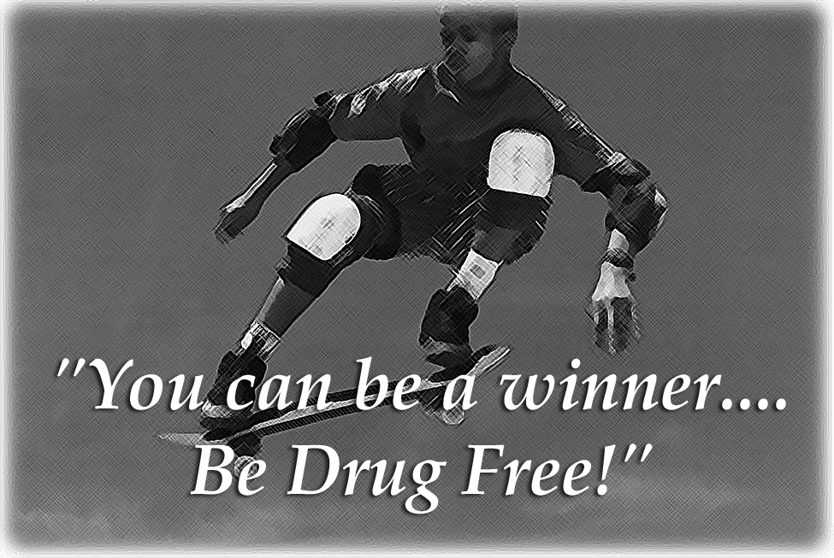
What can you do if a friend gets into trouble and overdoses on a drug or consumes excessive amounts of alcohol? If the situation permits, before doing anything else, call 911 and tell them what the person has taken, describe his or her symptoms, and seek advice on what action to take. In general, follow these rules:
- If the victim is conscious and took the overdose in the last thirty minutes, make him or her vomit.
- Keep the victim awake and conscious.
- Protect overly active, aggressive, or panic-stricken victims from hurting themselves, you, or others.
- Place an unconscious victim on his or her side, so that if the victim vomits, he or she will not choke or drown in it. This position also allows good respiration.
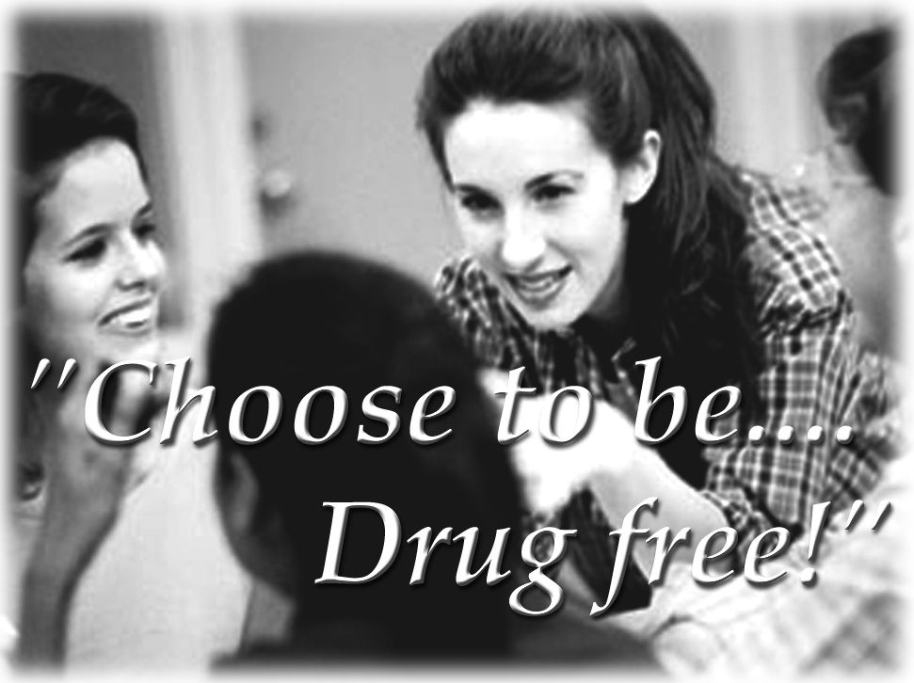
- Monitor the victim’s breathing.
- Maintain the victim’s body temperature.
- Reassure the victim that he or she will be okay.
- If the victim is having convulsions, do not put anything in his or her mouth. Clear away furniture and sharp objects, and move the victim only if he or she is near a fire, glass door, stairway, or other danger.
- Keep any evidence, including any material vomited, to help medical personnel determine what and how much the person took.
- Call for emergency medical services or transport the victim to a hospital or doctor.

Conclusion
Become involved as an individual. Talk to your friends and neighbors about drugs. Ask them to join you in your community's attack on drugs. Reach out a helping hand to your community – join the fight against drugs and become a part of the solution. Your assistance could save a life. 

